**Create scripts for networking – Project 2 (Documentation)**

*Dylan Armstrong (J2GA)*

Screenshots from Testing :-

Task 1

Set executable permissions of the script

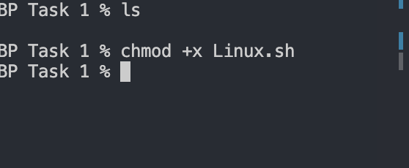

Set a cron job to run the Linux.sh script



Task 2

Searched for Argentine footballers within the Footballers.txt file

Searched for Soccer Teams within the footballers.txt file.

Task 3

Calculator ALGORITHM PLAN:

BEGIN

WHILE IS TRUE

DO

PROMPT USER FOR FIRST NUMBER

STORE FIRST NUMBER

PROMPT USER FOR SECOND NUMBER

STORE SECOND NUMBER

PROMPT USER FOR OPERAETION

STORE OPERATION

IF OPERATION IS “+”

PRINT ANSWER (Num1 + Num2)

IF OPERATION IS “-”

PRINT ANSWER (Num1 - Num2)

IF OPERATION IS “*”

PRINT ANSWER (Num1 * Num2)

IF OPERATION IS “/”

PRINT ANSWER (Num1 / Num2)

END

Task 5

Uploaded to GitHub using git: <https://github.com/da8998/rmit-script-project>

